Presented by: UAS PRogram OFfice
north carolina department of transportation
1050 Meridian Drive, Morrisville, NC, 27560

UAS Operational Procedures Guide
best practices series
Version 1.0
February 1, 2017
Operational Procedures under 14 CFR Part 107 Small Unmanned Aircraft Systems
Table of Contents
0
Introduction 2
Key actors 2
Practice description 2
1. Pre-flight operations 3
2. During flight operations 7
3. Post flight operations 8
4. Emergency procedures 9
5. Flight Area/perimeter management 11
6. Accident reporting 12
7. Flight crew communications 13
8. External communications 14
References: 15

Introduction
All UAS operators should develop and document operational procedures for their organization that will serve to guide flight operations planning and execution. The operational procedures document best practices and internal processes for safe and effective flight operations. This includes roles and responsibilities, mission phases, and emergency procedures. The aim is to document everything that needs to be done during a mission, so it can act as a reference point for team members. The information below is provided as a guideline for organizations to use in their own development of Operational Procedures specific to their organization and the types of flight operations they conducted under 14 CFR Part 107. However, not all of these guidelines will apply to all situations. Therefore, use your best judgment and error to the side of safety.
This document will not review in detail federal or state regulatory requirements for commercial and government UAS operations in North Carolina. For more detail on UAS operational requirements and limitations under 14 CFR Part 107, review FAA Advisory Circular AC 107-2, or the 14 CFR Part 107 small Unmanned Aircraft Systems (sUAS), links are provided at the end of this document. For more detail on UAS operational requirements and limitations under North Carolina General Statutes and to obtain a NC UAS operators permit, visit the NCDOT Division of Aviation website, a link is provided at the end of this document.

Key actors
- Remote Pilot (RP) a.k.a. Remote Pilot in Command (RPIC)
- Person Manipulating the Controls (PMC)
- Visual Observer (VO) or Multiple Visual Observer’s (VO)
- Airport Manager
- Air Traffic Controller
- Land Owner or Designated Party For Launch and Recovery Site

practice description
There are 8 sections to the practice: Pre-flight Operations, During Flight Operations, Post-flight Operations, Emergency Procedures, Flight Area/Perimeter Management, Accident/Incident Reporting, Flight Crew Communications, and External Communications. Each section will be reviewed in detail throughout this operational procedure document. Once organizations develop their own Operational Procedures, it is recommended that the organization complete training on a regular interval to maintain proficiency.

1. Pre-flight operations
Preflight activities are the duty of the RPIC before the start of the flight operation. Activities include inspection of the aircraft, assessment of the operating location, briefing crew members involved in the operation, and equipment checkouts. All flight operations should be conducted in accordance with the provision of 14 CFR Part 107, state and local regulations, and the operator’s manual for the subject aircraft.

Planning
- The flight crew should be familiarized with all available information pertaining to the flight such as; take-off/landing, including but not limited to the operational limitations of Part 107, weather conditions, hazards, no fly zones, etc.
- North Carolina state statues require land-owner approval before operations take place.
- RPIC will ensure the location for take-off and emergency landing is adequate upon arrival at the location. At least one emergency landing area should be identified before the start of operations.
- RPIC should be aware of all surroundings in the event that an emergency landing is necessary. This includes the ability to recover the UAS.

inspection
- Before the first flight of the day, verify all batteries are fully charged.
- Check the airframe for signs of damage, and its overall condition.
- Check the entire aircraft per the pre-flight inspection instructions in the manual for the specific aircraft to make sure it is in good structural condition and no parts are damaged, loose, or missing.
- Check the propeller or rotor blades for chips, cracks, looseness and any deformation.
- Check that camera(s) and mounting systems are secure and operational.
- Perform an overall visual check of the aircraft prior to arming any power systems.
- Repair or replace any part found to be unsuitable to fly during the pre-flight procedures prior to takeoff.

Weather
- Before each flight the RPIC and observer should ensure that he/she gathers enough information about the existing and anticipated near-term weather conditions throughout the entire mission environment. As a best practice he/she should utilize FAA approved weather resources such as; Meteorological Terminal Aviation Weather Reports (METARS), Terminal Area Forecasts (TAF), etc. to obtain the best information. In order to obtain the latest and most current weather conditions, Notices to Airmen (NOTAMs), and Temporary Flight Restrictions (TFRs) the RPIC should obtain a local aviation briefing at; 1-800-WXBRIEF or www.1800WXBRIEF.com.
- Wind direction plays a major factor in flight operations. Operators should take precautions to ensure that wind conditions do not exceed the aircraft limits stated in the aircraft operations manual/specifications. An anemometer (pocket anemometers are available from a variety of sources) is a low-cost and simple to use tool that can be utilized in order to better estimate the wind speed and determine if it is within the necessary limits of the UAS being flown. Use of an anemometer is highly recommended, in particular in cases where wind conditions and whether they are within limits may be questionable.
- The RPIC should ensure that the flight will occur within the weather requirements specified in Part 107.51 (c-d), 3 statute miles, the UA must be kept at least 500 ft. below a cloud and at least 2,000 ft. horizontally from a cloud. While the FAA can obtain waivers under Part 107 for certain types of operations in particular locations for night-time or beyond line of sight operations, the vast majority of authorizations are for FAA VFR conditions and require Visual Line of Sight (VLOS) between the aircraft and the UAS Operator as well as between the aircraft and the Visual Observer at all times.

Checklist
Preflight inspection is required under Part 107.49; the RPIC is required to develop a preflight inspection checklist if the manufacture has not developed one.
The checklist is usually integrated into the UAS flight software or can be obtained from the UAS vendor. In case that is not available, a standard Flight Checklist (Figure 1) should be made and followed by the flight crew. RPIC should utilize the checklist to ensure the highest level of safety. At a minimum, this pre-flight checklist should contain the following:
- Required documentation, Pilots Certificate, NC State Operators Permit, Aircraft Registration, UAS Flight Manual, Proof of Insurance.
- Weather conditions suitable.
- Check air frame for cracks and check all screws are tight.
- Propeller(s)/Rotor(s) not damaged and tightly fixed.
- Propulsion system mounting(s) secure.
- Batteries fully charged and securely mounted.
- Communications (datalink) check.
- Ensure the GPS module (if any) has GPS “fix.”
- Check mission flight plan.
- “Return Home” and/or “Emergency Landing” locations (if supported by the particular UAS) are selected, located appropriately, and loaded to the GCS and aircraft.
- Ensure sensors are calibrated and that the right setting is loaded.
- Complete flight crew briefing.
- Ensure the launch site is free of obstacles.
- Recheck wind direction before launch.
- Confirm phone number for nearest Air Traffic Control facility in event of emergency.

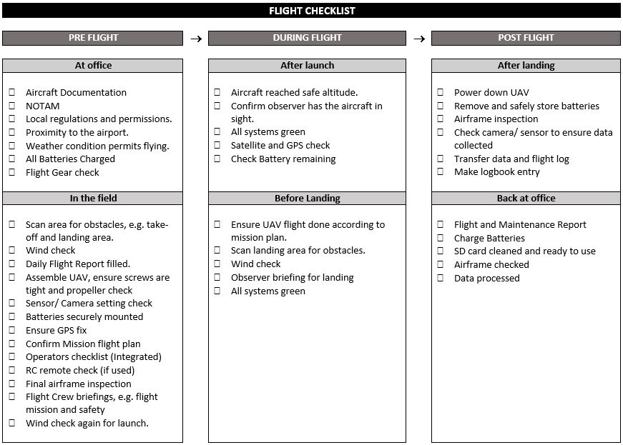
Figure 1: Example of a Flight Checklist*
* This checklist is considered a guide and not definitive checklist for all UAS's. Use common sense when operating UAS's. Consult local UAS agency or vendors to ensure your checklist is appropriate.

documentation
Once the RPIC confirms the location is safe to fly and becomes familiarized with the surroundings, it is recommended that he/she document all the details in a Pre Flight Report. The Pre Flight Report can often be filled out prior to arrival at the site as a part of mission planning and then signed off by the RPIC once on site and the RPIC has confirmed that the operation can be conducted safely at the site. Furthermore, it is recommended that such a report be completed for each mission regardless of whether it is completed prior to or after the flight as the report serves as an essential piece of documentation associated with the UAS operation.
An example of what the report should contain is:
- Altitudes to be flown
- Mission overview
- Frequencies to be used
- Planned flight time, including reserve fuel requirements
- Contingency procedures
- Pilot Name
- Observer(s) name(s)
- Date & Time
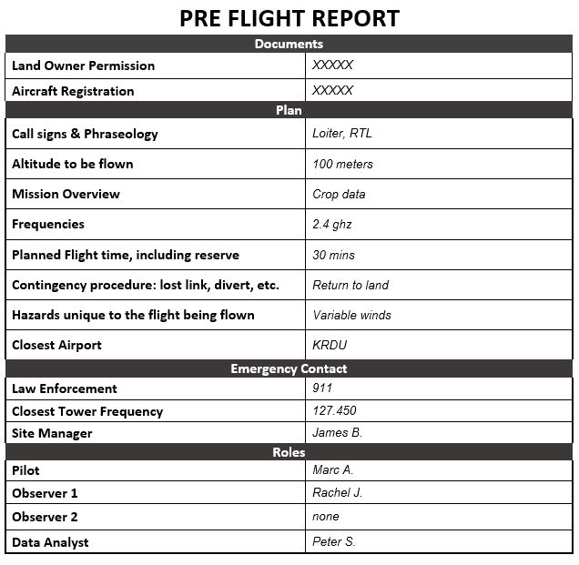
Figure 2: Example of a Pre-Flight Report*
* This report is considered a guide and not definitive report for all UAS’s. Use common sense when operating UAS’s. Consult local UAS agency or vendors to ensure your checklist is appropriate.

2. during flight operations
- The UAS RPIC should launch, operate, and recover from preset locations so that the aircraft will fly according to the mission plan.
- After the UAS is launched, the flight crew should have a clear view of the aircraft at all times, called Visual Line of Sight (VLOS). Observation locations should be selected for the maximum line of sight throughout the planned flight operations area (Part 107.31).
- All flight operations must be conducted using a minimum of a RP and PMC per Part 107.31. However it is advisable to utilize one or more VO’s, as outlined in Part 107.33, depending on the complexity of the flight mission to perform general safety, visual observation, hazard and traffic avoidance (Part 107.37).
- To ensure the flight is going according to the flight plan, the RP, PMC and VO (if used) must be able to maintain effective communication with each other at all times (Part 107.33).
- The visual observer should be informed on what the aircraft is supposed to be doing and the altitude of the aircraft above ground level.
- Part 107.39 does not permit UAS flights over persons not directly involved in the operations. Flights taking place over populated areas, heavily trafficked roads, or an open-air assembly of people is not allowed under regulation (unless through waiver). If the mission dictates that flight operations be conducted in such areas, the RPIC will need to obtain a waiver before conducting a flight.
- The observer should make the pilot aware of any possible flight hazards during the flight.
- Upon any failure during the flight or any loss of visual contact with the UAS, the RPIC should command the aircraft back to the recovery location or utilize the built-in fail-safe features to recover the aircraft. Emergency procedures as defined in the specific UAS operator’s manual should be followed.

3. POST flight operations
- RPIC should scan the landing area for potential obstruction hazards and recheck weather conditions.
- RPIC should announce to the observer and any other people around that the aircraft is on final approach and inbound to land.
- RPIC should always be prepared to reject or abort a take-off or landing, called a “go-around,” if the PMC becomes aware that such an operation cannot be safety made due to an unexpected weather situation, emergency, hazard or miscalculation.
- Carefully land the aircraft away from any obstructions and people.
- After landing:
  - Shut down the UAS and disconnect the batteries.
  - Power down the camera or sensors.
  - Visually check aircraft for signs of damage and/or excessive wear.
  - Verify that mission objectives have been met.
  - If imagery or other data are recoded onboard the aircraft during flight, transfer the data as necessary to the Ground Control Station (GCS) or a backup storage devise. If all data and imagery is transmitted to the GCS and recorded on the GCS during the flight, then operators may wish to consider backing up the data prior conducting additional flight operations.
  - Enter logbook entries recording flight time and other flight details.
  - In case there are multiple flights to be conducted, repeat checklist steps to prepare the aircraft for launch again.

4. Emergency procedures
Emergency procedures are specific to each UAS type as designed by the manufacturer. It is the responsibility of the flight crew to be proficient with the aircraft operational manual provided by the vendor before any flight operations are conducted. It is also a best and safe practice to prepare an Emergency Checklist (Figure 3) in case of emergencies. The RPIC should always be prepared to execute an emergency procedure in instances where there is a lost link, loss of GPS, or there are other aircraft or obstructions in the flight path. He/she should brief the flight crew before the start of the flight operations about emergency procedures and have a mission abort site for landing in the case of an emergency. After the aircraft has safely landed, it should be documented for maintenance purposes.
Some possible emergencies due to system failures are as follows:
- Loss of Datalink communications
- Loss of GPS
- Autopilot Software error/failure
- Loss of Engine power
- Ground Control System failure
- Intrusion of another aircraft into the UAS mission airspace

This is not meant to be a comprehensive list as the types of failures and associated emergency conditions vary for different UAS, airspace events, and crew performance.

Many UAS have a number of failsafe options in case of failures or emergency situations. These include using methods of stabilization and an automated Return to Land (RTL) or Loiter mode. Other features include fail-recovery software. The specific failsafe options available for each type of UAS should be outlined in the UAS documentation (Operator’s Manual, Checklists, etc.). These fail-safe mechanisms should be tested during training and currency flights. Flying without these fail-safe mechanisms in place is not recommended.
An emergency avoidance procedure should be determined before landing. Options include land immediately, move to a predetermined location and altitude, or another approach. All possible incursions must be assessed for risk mitigation.
In the event of a lost link or fly away, the RPIC should evaluate the airspace affected and contact the appropriate controlling agency (i.e. control tower, airport manager, Center, Restricted Area agency, etc.) immediately with details of the flight such as; location, direction of flight and approximate altitude, speed and flight time remaining (remaining battery life) .
In the event of an emergency the RPIC should be prepared to submit a written statement on any deviations upon the request of the Administrator (FAA) as outline in Part 107.21. Best practices suggest that the RPIC fill out a NASA Aviation Safety Reporting System (ASRS) Electronic Report Submission (ERS). More information about this program can be found at: https://asrs.arc.nasa.gov/overview/summary.html. Note: The NASA ARRS system was developed to encourage pilots, aviation maintenance technicians and other personnel to disclose mistakes in a non-punitive format in an effort to advance safety. In exchange for volunteering information the person reporting the infraction may receive a reduced penalty if the FAA pursues certificate action.
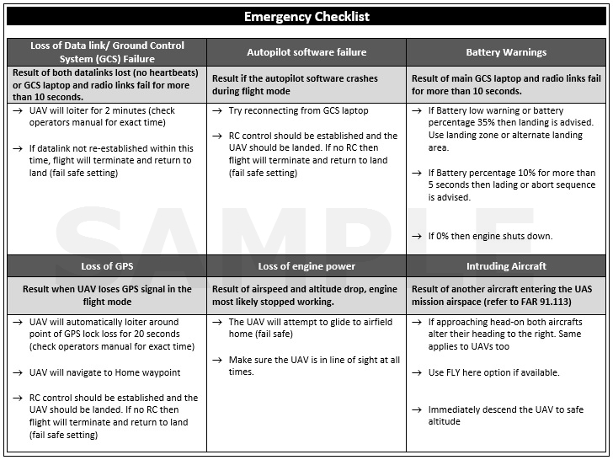
Figure 3: Example of an Emergency Checklist*
* This checklist is considered a guide and not definitive checklist for all UAS’s. Use common sense when operating UAS’s. Consult local UAS agency or vendors to ensure your checklist is appropriate.

5. Flight Area / perimeter management
The selection of launch and landing sites is based first and foremost on safety. It is the job of the RPIC to ensure that all flight operations are within the FAA-issued airspace authorization parameters and UAS flight limits. Flight boundaries, including any restrictions imposed by FAA approvals, nearby airport locations, restricted areas, TFRs, etc. should be reviewed prior to commencing flight operations. In addition, the RPIC should identify the following:
- Primary Take-off and Landing site - Typically the primary landing shall be the same as the launch site but they can be separate locations. The RPIC has final authority for any approaches to the primary site and elect to reject an approach deemed unsafe.
- Alternate landing sites - The RPIC shall designate at least one alternate landing site. In the event that a landing is not possible and the primary landing site is deemed unsafe, procedures to utilize the back-up site will be invoked.
- Mission Abort Sites - The RPIC may optionally designate an alternate landing site whereby the aircraft may be landed in directly in an emergency situation. The alternate landing site should be located so as to provide absolute minimal risk if the aircraft is required to vacate airspace in an emergency. If the RPIC deems it necessary, the UAS may be flown to this site and landed without regard to the risk to the flight equipment or the unmanned aircraft. The safety of persons, manned aircraft, and property should be prioritized over the risk to the UAS equipment.
- Flight Over populated areas- The RPIC should make every effort to select a landing site that avoids approaches over populated areas.
- Landing Safety & Crowd control - All landing sites should be maintained and operated in the same manner as the launch sites. A buffer of at least 50 feet should be maintained at all times between aircraft operations and all nonessential personnel (all personnel other than the UAS Operator/RPIC and the Visual Observer).

6. accident reporting
Within 10 calendar days after an accident (as defined by regulation) and before additional flights, the operator must provide notification to the FAA per Part 107.9.
FAA defines an accident when:
- Any person suffers death or serious injury.
- Damage to any property, other than the small UAS if the cost is greater than $500 to repair or replace the property.
The accident report can be submitted FAA Regional Operations Center (ROC) electronically (https://www.faa.gov/uas/report_accident/) or by telephone using the following directory:
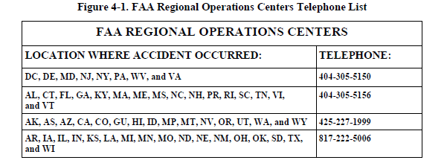
Source: FAA Advisory Circular (AC) 107-2
The ROC Reports may also be made to the nearest jurisdictional FSDO (https://www.faa.gov/about/office_org/field_offices/fsdo/). The report should include the following information:
- RPIC’s name and contact information;
- RPIC’s FAA airman certification number;
- sUAS registration number issued to the aircraft, if required (FAA registration number);
- Location of the accident:
- Date of the accident;
- Time of the accident;
- Person(s) injured and extent of injury, if any or known;
- Property damaged and extent of damage, if any or known; and
- Description of what happened.
SUAS accidents are reported to the FAA ROC. However, in some cases, according to FAA AC 107-2 (4.5.2), a sUAS accident must be reported to the National Transportation Safety Board (NTSB). The AC directs the RPIC reporting an accident to the FAA to consult the NTSB website (www.ntsb.gov) for more information. It is important to understand the regulations so that proper reports and notifications can be prepared following an accident. Enforcement action can be taken against the operator if notification is not made within the prescribed timeframe.

7. flight crew communications
The knowledge of flight management process flows is crucial for effective communication. It is important for the RPIC, Person Manipulating the Controls, Visual Observer(s), and other essential flight personnel to maintain communication at all times. During all operations observer and other flight personnel to acknowledge that he/she received a message. This way the flight crew can coordinate flight operations in an organized and effective manner. A proper decision making structure (communications plan) should be identified prior to Pre Flight Operations and should be followed by the flight crew at all times, i.e. (in-order of the hierarchy from highest to lowest) RPIC, Person Manipulating the Controls and the Visual Observer(s).

8. external COmmunications
Waiver must be obtained before flight operations are conducted in Class B, C, D, and E airspace. The FAA maintains a website to file waivers.
- https://www.faa.gov/uas/request_waiver/
Instructions for filling out the waiver are linked to the website link above. Applications with incomplete or incorrect information will be rejected. The RPIC will need to follow the provisions of the waiver which will vary by location.
According to AC 107-2 5.8.1, “Unless the flight is conducted within controlled airspace, no notification or authorization is necessary to operate at or near an airport.” When operating in the vicinity of an airport, the RPIC must be aware of all traffic patterns and approach corridors to runways and landing areas (AC 107-2 5.8.1, 5.8.1.1, 5.8.1.2). Operations in the vicinity of airports in uncontrolled airspace do not require airport operator/management notification. However, adherence to CFR 107.43 “Operations in the vicinity of airports” is required. 107.43 states, “No person may operate a small unmanned aircraft in a manner that interferes with operations and traffic patterns at any airport, heliport, or seaplane base.” As a result, it is important to allow for additional pre-flight planning time to become knowledgeable about the specific non-towered airport operations.
When operating in the vicinity of a non-towered airport within Class G Airspace two-way radio communication with the Common Traffic Advisory Frequency (CTAF) or Unicom is not required under Part 107. Never-the-less, it is recommend that the UAS flight crew monitor the airport’s CTAF or Unicom, and be familiar with airport operations and radio communication procedures. It is also best practice to have the local emergency responder’s phone number on hand in case of emergencies.

References:
- Final Rule of FAA Part 107:
https://www.federalregister.gov/documents/2016/06/28/2016-15079/operation-and-certification-of-small-unmanned-aircraft-systems

- FAA Advisory Circular 107 – 2: https://www.faa.gov/documentlibrary/media/advisory_circular/ac_107-2.pdf

- NCDOT Division of Aviation website: https://www.ncdot.gov/aviation/uas

